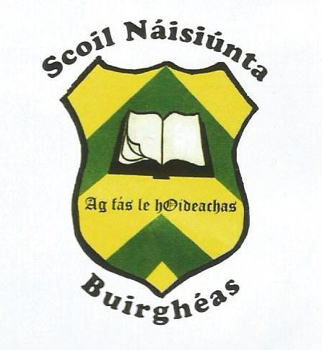
1081Burgess National School
CARRIGATOHER, NENAGH, CO. TIPPERARY.

Roll No. 18164G
Tel. 067-34515 email: burgessns@eircom.net
October, 2018

Congratulations: Well done to our athletes from third to sixth class, who made us proud both with their performance and success in the county Tipperary primary schools cross country championships, held in Thurles on September 26th. The pupils won team and individual medals and enjoyed participating with children from schools all over the county. Thanks to Ms. Mc Loughlin for organising training during lunch time in preparation for the event. Burgess N.S. also had great success in Gaelic Football winning both the U-11 and U-13 North Tipperary Cumann na mbunscol championships. Thanks to Mr. Sheehy for training the teams during lunch breaks. We would also like to congratulate the Senior men’s team and the Duharra camogie team on once again bringing glory to the parish and we join in honouring the celebrated team of 1993.
Busy September: Pupils had great fun on National Fitness Day taking on the Teachers Challenge. They enjoyed a penalty shoot-out against Mr. Sheehy and basketball shooting against the rest of the staff. They also participated in an obstacle course and skipped their way to fitness. The CIR Recycle team visited the school to give a workshop on good practice when recycling. This will be of benefit to the pupils who hope to attain our sixth Green Flag under the theme of Global citizenship and Litter this school year. Burgess school participated in the Stay Safe Stay Clear programme sponsored by the ESB. Pupils engaged in five lesson activities and created powerline safety posters. We also had a visit from John Slattery and Conor Ryan who answered many complicated questions posed by the pupils.
Artist in the primary school scheme: Thanks to Tipperary Co. Council, Burgess pupils are thoroughly engaged in our Bronze Age project titled “Times Past” with artist Lian Callaghan. As they revisit the past they are learning many art and craft skills including willow weaving, costume/jewellery making, crannog building, pottery, wool spindling and straw rope making. The project will culminate with a presentation for the parents, date to be confirmed later.
Creative writing workshop: We look forward to welcoming award winning presenter and children’s author Anthony Garvey to our school on November 12th Anthony will give the first of two workshops on creative writing to pupils from 3rd to 6th class. Pupils from junior infants to second class will enjoy a book reading with the author.
Book Sale: We hope to run a book sale after the midterm break. Pupils can donate unwanted children’s books (no school books) and these books can then be purchased for €1 each.
Halloween Activities: On Thursday the 25th, pupils will have the opportunity to dress up for Halloween and 4th, 5th and 6th class pupils will hold a bake sale for the rest of the school, cost per bun 50c. The money raised from the book sale and bake sale will go towards off setting some of the cost of the author’s visit.
Parking: We would like to remind parents not to park in front of teacher’s car parking spots, on arrival and collection from school. Pre-school and school staff need access to arrive and leave without hindrance. We look forward to your co-operation regarding this matter.
Team Hope shoebox collection: Once again we invite pupils to participate in the Team Hope shoebox appeal. Leaflets will be distributed during the week and those interested in participating can return their shoe box to the school after the mid-term break.
Parent-Teacher Meetings: Parent-Teacher meetings will take place in the school hall on Wednesday 15th of November, commencing at 2p.m. and finishing at 4p.m. Parents will be given allocated times after mid-term. All children will finish school at 2 p.m. on that day.
At the end of the meeting please confirm your preferred time slot for assisting with money collection at our annual street fundraiser in Nenagh, Wednesday, December 19th : 9.30-11.00, 11.00-12.30, 12.30-2.00, 2.00-3.30, 3.30-5.00 The success of this fundraiser relies on your assistance.

Slán agus Beannacht: We would like to take this opportunity to thank Margaret Ryan for her outstanding work cleaning the school over the years. Her work was always of the highest standard. We wish her well in her new position.
Thanks: We are extremely grateful to all those who dropped in clothes for recycling. The recent collection weighed 800kg. Another collection date will be announced in the New Year. Donations of clothes are welcome at any time.

