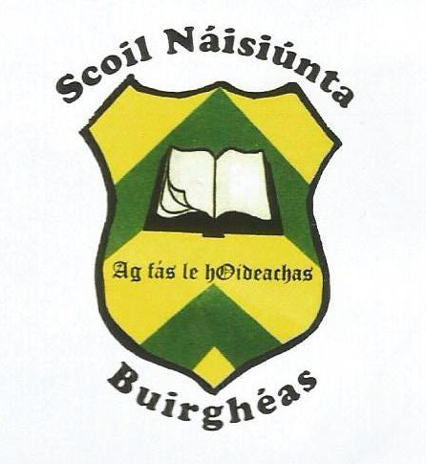
Burgess National School
CARRIGATOHER, NENAGH, CO. TIPPERARY.

Roll No. 18164G
Tel. 067-34515 email: burgessns@eircom.net

November, 2018

Stem Day: During Science week pupils from fourth to sixth class had a very enjoyable day at Nenagh College. They participated in a wide variety of activities: P.E. Woodwork, Metalwork, Home Economics, Coding and Science. They also enjoyed food in the school canteen. We are very thankful to Nenagh College for their kindness and welcome on the day.
Christmas Annuals Reminder: The Christmas annuals are €2 each, there are four levels to cater for all the pupils. Annuals will be handed out to pupils in the first week of December so please place your order with payment as soon as possible.
“Times Past”: Burgess goes Bronze
Our Bronze age project with artist Lian Callaghan is nearing completion. We would like to thank Conor Mulcahy for giving his time and assistance in roofing the crannog. We are delighted to invite parents to take a trip back in time and experience the Bronze age through the creative work of the children. From 2p.m. to 3p.m. on Friday Nov. 30th with a short video presentation at 2.30 p.m. you will have the opportunity to talk to the children about their art and craft and learn about life in Burgess during the Bronze age. All are welcome!
Bake Sale/Book Sale: Thank you to all the bakers who made delicious treats. The activity raised €185, which covers the cost of the first Creative Writing Workshop. The second workshop will take place in February. Keep bringing in unwanted children’s books as we will have our book sale soon.
Annual Fundraiser: We would like to thank all those parents who have offered to help out with the bucket collection in Nenagh Dec 19th. We urge those who have yet to commit to a time slot to get back to the school as soon as possible so that a rota can be compiled. At present there are many time slots yet to be filled so please help out if you can. Junior and Senior Infants will finish school at 12.30 p.m. on this date as they are not participating in the event.

Carol service: Burgess School will hold a carol service in Ballywilliam church at 7.00p.m. on Thursday 13th Dec. All classes will be involved, pupils are to wear their school uniform and a Santa hat. On the night there will be a donation box at the door in aid of Focus Ireland Children’s Christmas appeal.
Snow White Christmas Panto: Junior and Senior Infants will attend Snow White in University Concert Hall Limerick on Dec. 20th. The cost of ticket and bus per child is €20 which is subsidised by the school. Pupils will leave the school at 9.00a.m. and return before 2’oclock.
North Tipperary Primary Schools GAA Quiz: will take place in Kilruane Mc Donaghs Complex in Cloughjordan on Sunday the 25th Nov. commencing at 6p.m. Good luck to all involved.
School Closure: The school will close at 12.00pm on Friday 21st December and reopen on Monday 7th January 2019.

Calendar of Events:
25/11/18 GAA Quiz
13/12/18 Carol service in church 7.00 pm
19/12/18 Carols Street Collection Nenagh
20/12/18 Infants-UCH Christmas Pantomime
21/12/18 School Closes 12.00pm
07/01/19 School Re-opens

