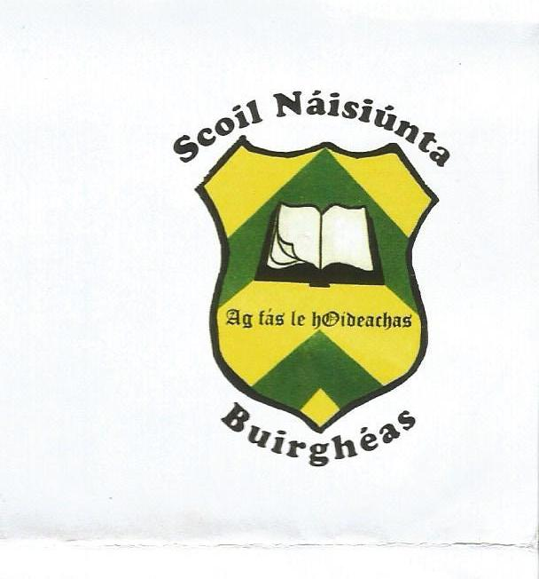

Burgess National School
ANNUAL ADMISSION NOTICE
in respect of admissions to the 2023/2024 school year

Admission Policy and Application Form
A copy of the school’s Admission Policy and the Application Form for Admission for Burgess National School is available as follows: –
To download at:burgessns.weebly.com
On request: By emailing info@burgessns.com or writing to : Burgess NS,Carrigatoher, Nenagh, Co.Tipperary

PART 1 - Admissions to the 2023/2024 school year

Application and Decision Dates for admission to Burgess National School 2023/2024
The following are the dates applicable for admission to Junior Infants
The school will commence accepting applications for admission on | 1st October 2022
The school shall cease accepting applications for admission on | 31st March 2023
The date by which applicants will be notified of the decision on their application is | 21st April 2023
The period within which applicants must confirm acceptance of an offer of admission is | 4th May 2023

Note: the school will consider and issue decisions on late applications in accordance with the school’s admission policy.

Number of places being made available in Junior Infants 2023/2024

The number of places being made available in junior infants is | 15

